ESS – Unit testing Document
1.
only show the active employee
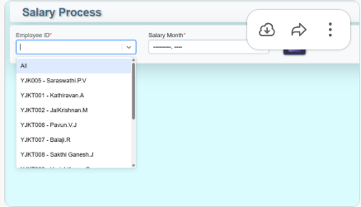

2.
*)please check the "Salary Process " --> sp taken hours "All Employee" or "Single Employee"
*) fix this bug "Pay slip " showing the month in number .but replace the month name like "2025 10" to "October 2025
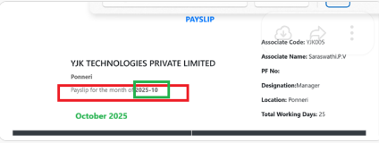

3.
please highlight the current tab for "Employee Info Screen " and sub screen

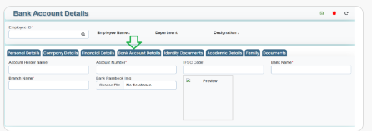

4.PMS- To add the status for “Export to Excel” Report
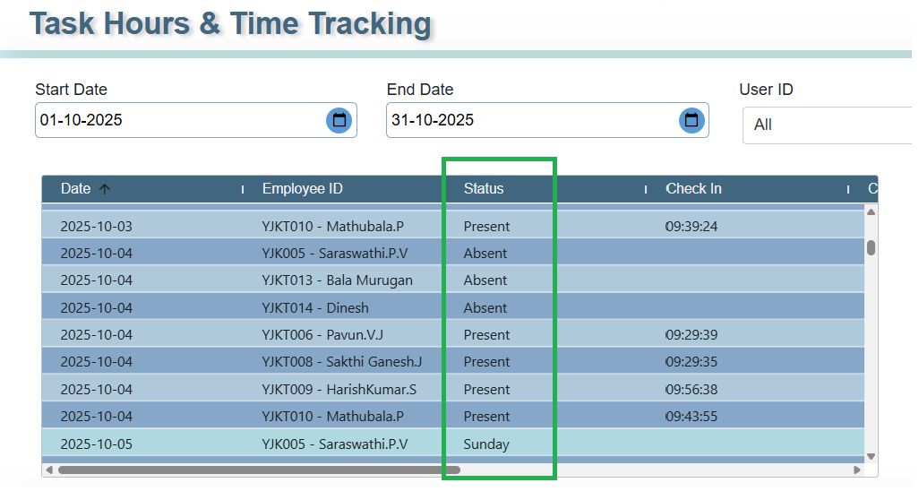

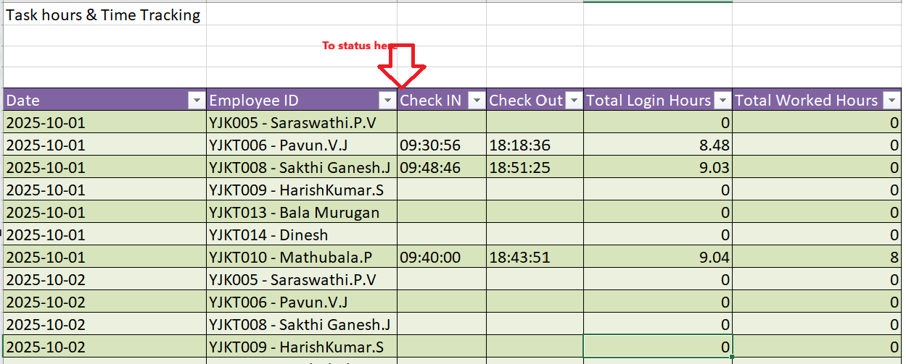

5.ESS- Employee info – update
Not working update button
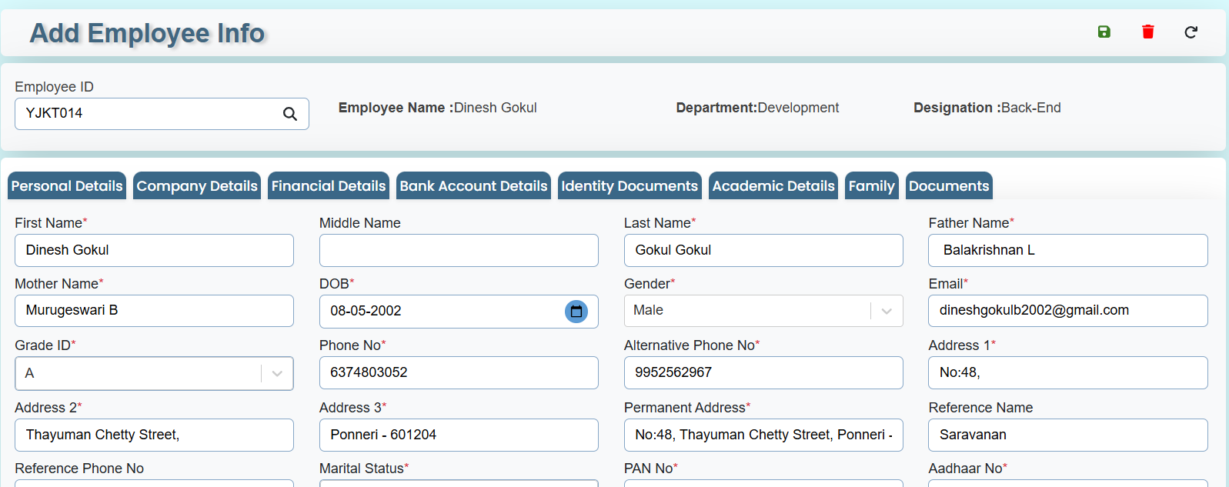

6.PMS-Task Hours & Time Tracking
please add one more table details for "Task Hours & Time Tracking" for "Export to Excel"
details "Current Leave status as of July 2025"
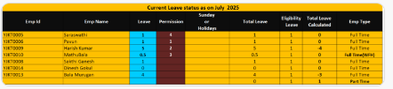

7.
1.ESS- EmployeeDashboard – to select the checkin and checkout details not showing the “Total Hours” please fix the bug
2.To add the “export to excel “option

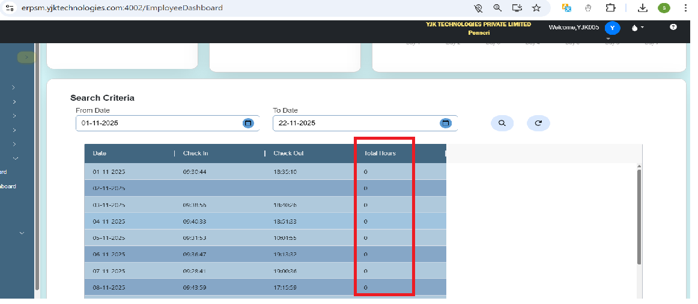

To the “Status”
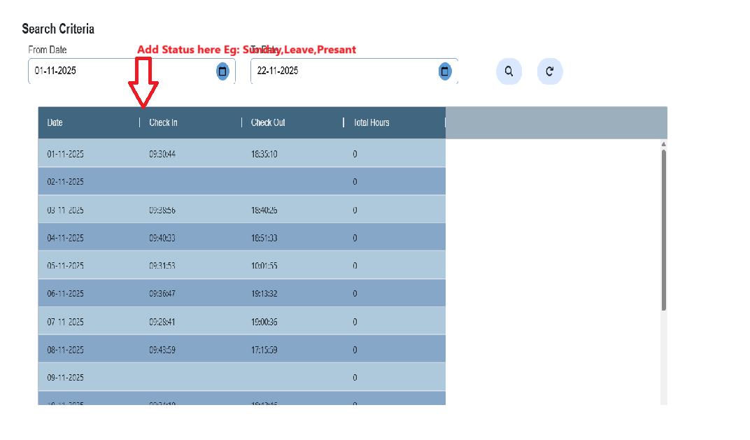
8.ESS- EmployeeDashboard - Pay slip Generate .
Report show the heading back groud color is block fix the color in visible in clear
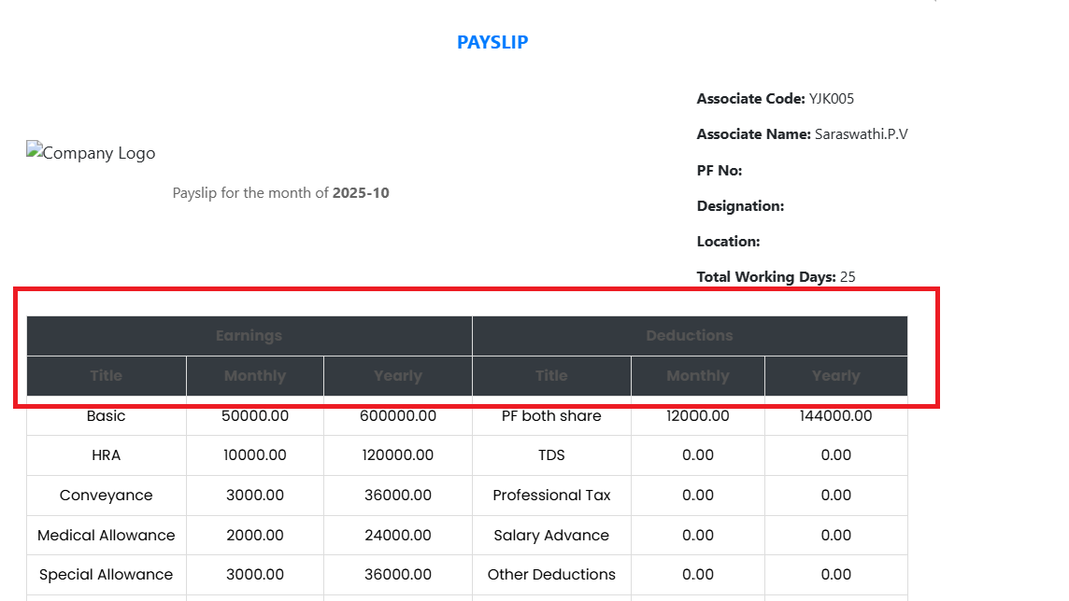

9.ESS- EmployeeDashboard - Alloted Holidays(Calendar)
Please align all frame same height
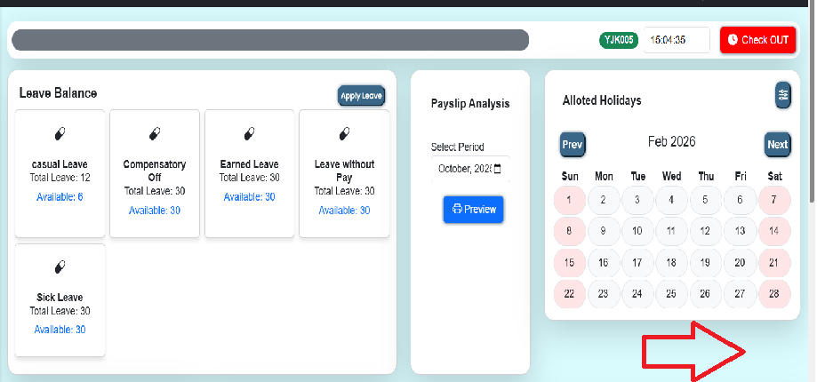

10.To add “ToolTip “ all the screen

1.Add Grade Details

2.Leave Type

3.Loan Details

4.Add Announcement

5.Employee Holiday

6.Payslip Master (All Screen or Tab)

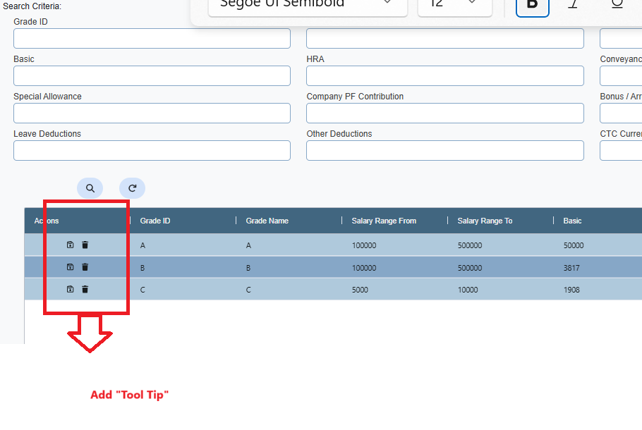
11.To add the Status ( "active","Close",All") Set DEfault is "Active"

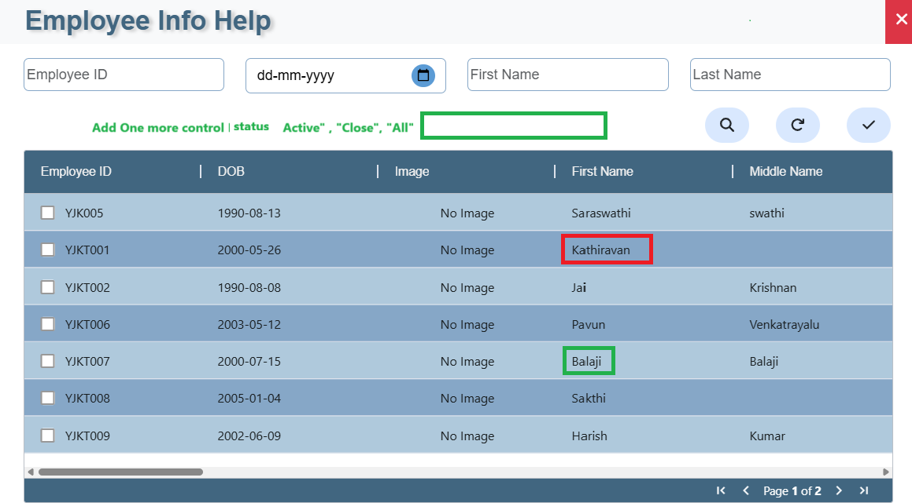

Update
12.update button pressed this issue showing 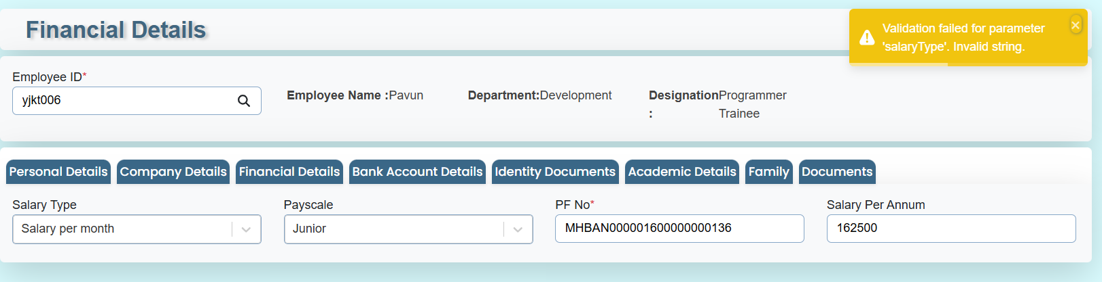

13.To add the filter for "status" close then showing the employee related to the filter for status is "colse"
fix this issue

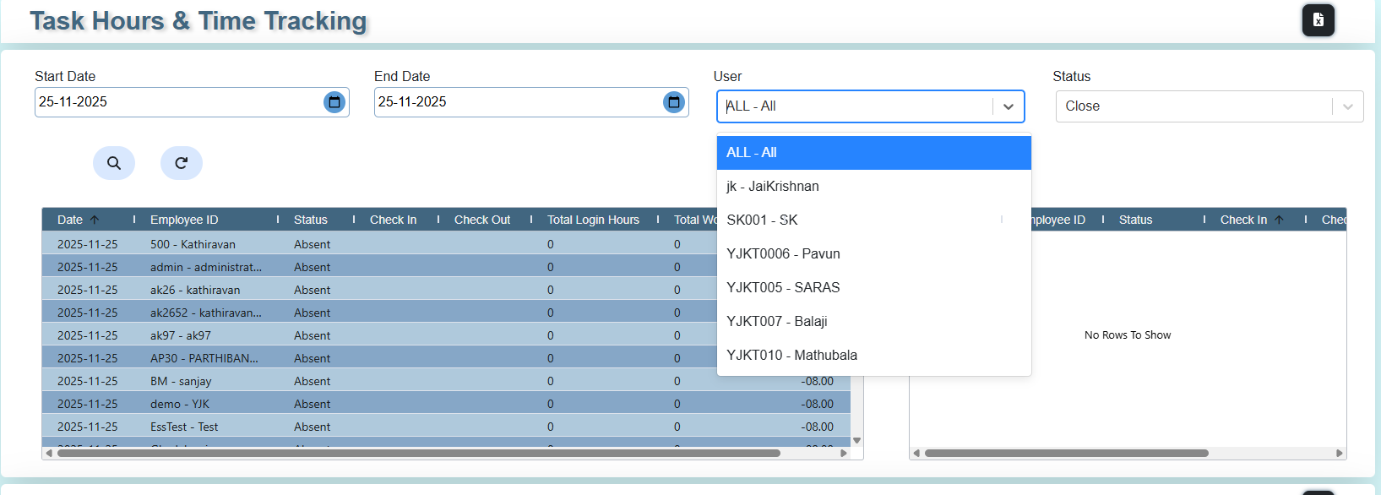

!4.PMS- i have selecte the any one task update the not display the details for "project and task "details screen

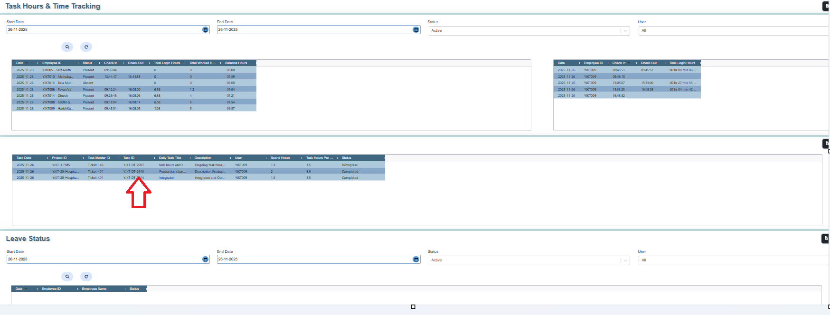

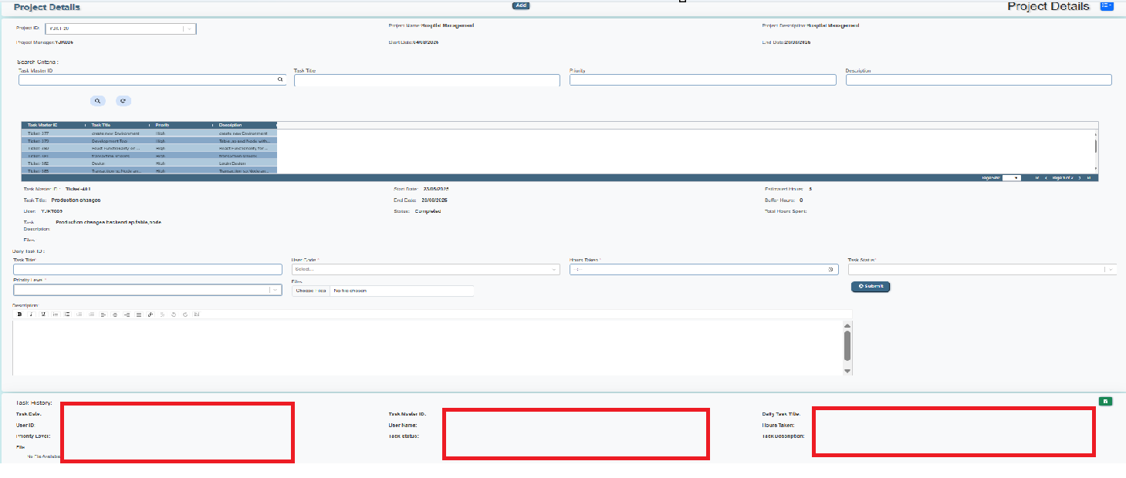

15. ESS-EmployeeInfo - updatation time showing the error (production server)

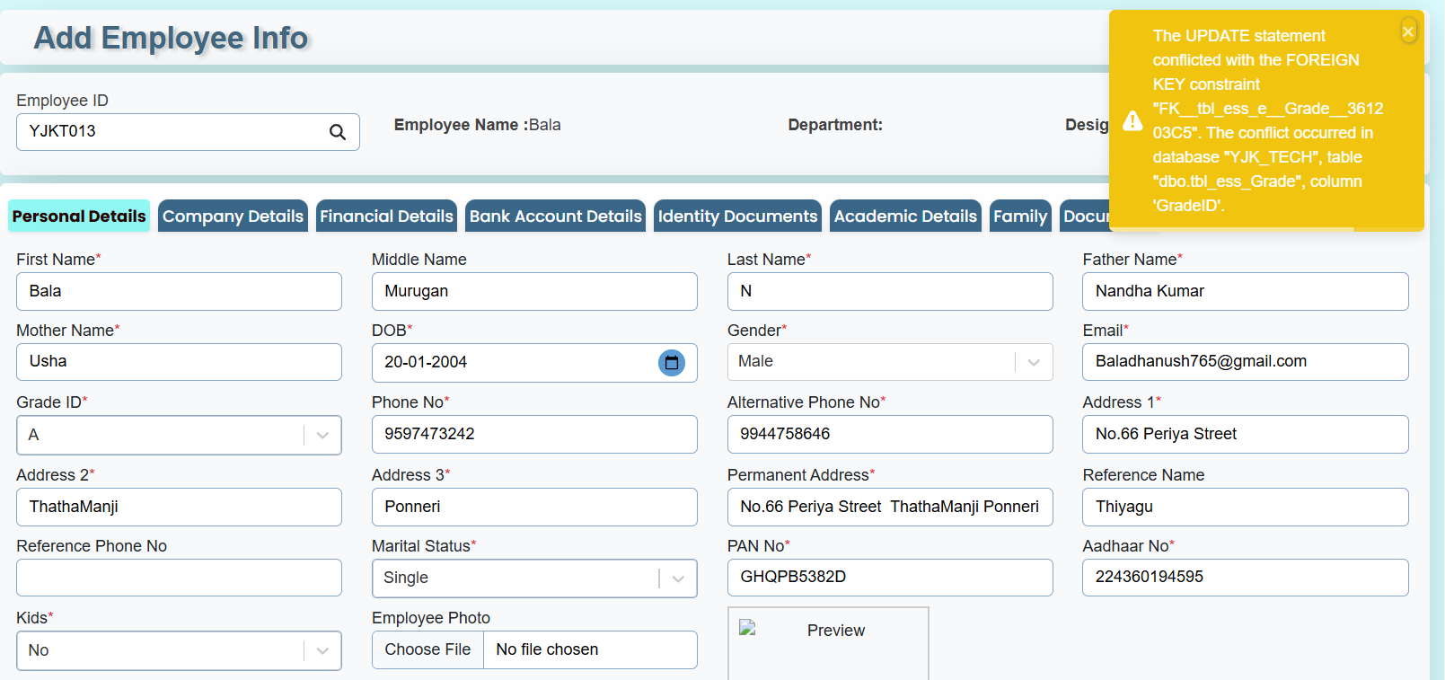
16.ESS- admin dashboard to replace the “Leave chart” button to “AttendanceDetails”

*) chart display then show the button label “AttendanceDetails”
*)data display then show button label ”Leave Chart”
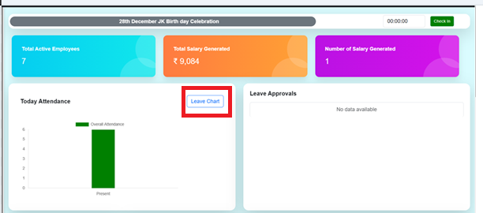
17.

